

**KE5108: Tutorial 1**

1. In a given gray level image, the gray level distributions of the pixels can be assumed to be represented by the following expression:

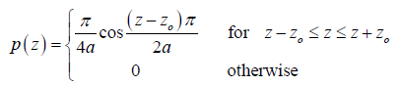

For the object, zo = 1, a= 1, and for the background, zo = 3, a= 2. From the histogram of the whole image, we can assume that object pixels occupy one-third of the total number of the pixels of the image.

i) Sketch the Probability Density Functions for the object and the background

ii) Determine the Optimal Threshold, based on minimum classification approach, of the image.

iii) Calculate the fraction of mis-classified object pixels based on the Optimal Threshold value you have obtained in (ii) above.

1. In a given gray level image, the gray level of the object pixels and the background pixels are distributed according to the following probability density functions, po and pb, respectively:

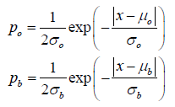

Where □ and b are respectively the means of the object and background distributions; and □ and b are the standard deviations of the object and background distributions, respectively.

1. If *T* is the optimal threshold and *λ* is the fraction of object pixels in the image, prove the following expression. You may use the conditions for Optimal Thresholding derived in the lecture notes without proving them.

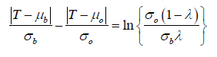

1. If □ = 60, b =40,□ =10, b =5 and the object occupies two-thirds of the image (*λ=*2/3), determine the optimal threshold value(s). [Hints, there might be multiple possible values of thresholds due to the presence of ABSOLUTE operator |• ].
2. The two probability density functions are plotted as shown in Fig. 2. In your opinion, what would be the reasonable value of the optimal threshold of the image? Explain your reason. Compare, with detailed explanation, your value with those obtained in Part (i) above.

